ProblemStatement:

IoT-BasedIndustry – Safety Gadget for Child Safety Monitoring and Notification

Domain:

Internet of Things

Assignment1:

Circuit design Home automation system in

TinkerCad

By,

Sajja Vijay

720819106087

Link: <https://www.tinkercad.com/things/frttRR6s91p-shiny-stantia-wolt/editel?tenant=circuits>

Circuitdiagram:

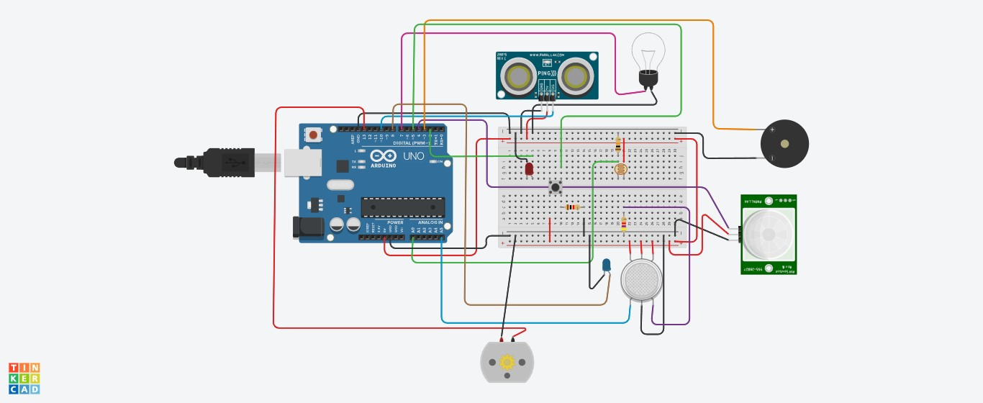

ArduinoUnoCode:

constintpingPin=10; constintledUS=2; constintlight=7; constintpir=4; #definephotoSensorA0 #definebuzzer3 intconstPINO_SGAS=A5; intconstledGas=8; intconstbutton=5; intconstmotor=13; voidsetup()

{

pinMode(ledUS,OUTPUT); pinMode(light,OUTPUT); pinMode(buzzer,OUTPUT); pinMode(ledGas,OUTPUT); pinMode(motor,OUTPUT); pinMode(pir,INPUT); pinMode(button,INPUT); pinMode(photoSensor,INPUT);

Serial.begin(9600);

}

voidloop()

{

longduration,cm; intvalLight=analogRead(photoSensor); intvalPIR=digitalRead(pir); intvalGAS=analogRead(PINO_SGAS); valGAS=map(valGAS,300,750,0,100); intvalBt=digitalRead(button); pinMode(pingPin,OUTPUT); digitalWrite(pingPin,LOW); delayMicroseconds(2); digitalWrite(pingPin,HIGH); delayMicroseconds(5); digitalWrite(pingPin,LOW); pinMode(pingPin,INPUT); duration=pulseIn(pingPin,HIGH); cm=microsecondsToCentimeters(duration); if(cm<336){

digitalWrite(ledUS,HIGH);

}else{ digitalWrite(ledUS,LOW);

}

if(valLight<890){

digitalWrite(light,HIGH);

}else{ digitalWrite(light,LOW);

}

if(valPIR==1){

digitalWrite(buzzer,HIGH);

}else{ digitalWrite(buzzer,LOW);

}

if(valBt==1){

digitalWrite(motor,HIGH);

}else{ digitalWrite(motor,LOW);

}

if(valGAS>20){

digitalWrite(ledGas,HIGH);

}else{ digitalWrite(ledGas,LOW);

}

Serial.print(valPIR);

Serial.println();

}

longmicrosecondsToCentimeters(longmicroseconds){

returnmicroseconds/29/2;

}